Technical design

Project Virtualisation
Team 2

Client: Arjen Jansen |  | Filename: | FD_v3.0.docx
Project Virtualisation |  | Version: | 3.0
Author: Rami Haddad, Kasper van Brakel,  Reinier van Rooij, Tim Dijkhuizen, Ingwar Verbeek |  | Date: | 21-12-2014

Document management

History
Version | Date | Changes (draft/final) | Client | Author(s)
1.0 | 29-09-2014 | Draft | Arjen Jansen | Rami Haddad, Kasper van Brakel,  Reinier van Rooij, Tim Dijkhuizen,  Rakis Bipat & Ingwar Verbeek
2.0 | 05-12-2014 | Draft | Arjen Jansen | Rami Haddad, Kasper van Brakel,  Reinier van Rooij, Tim Dijkhuizen, Ingwar Verbeek
3.0 | 21-12-2014 | Draft | Arjen Jansen | Rami Haddad, Kasper van Brakel,  Reinier van Rooij, Tim Dijkhuizen, Ingwar Verbeek

Approval
This document needs the following approvals.
Signed approval forms are stored in the Management section of the project archive.
Name | Role | Signature | Date document | Version

Table of contents

Document management 2
History 2
Approval 2
Table of contents 3
1. Introduction 4
2. Archimate 6
3. Network Design 7
4. Security 9

Introduction

This document describes the technical specifications of the virtualization platform made by ITopia for Plaintech. The document consist of schematics, diagrams and explanations of the details.

Archimate

Network Design

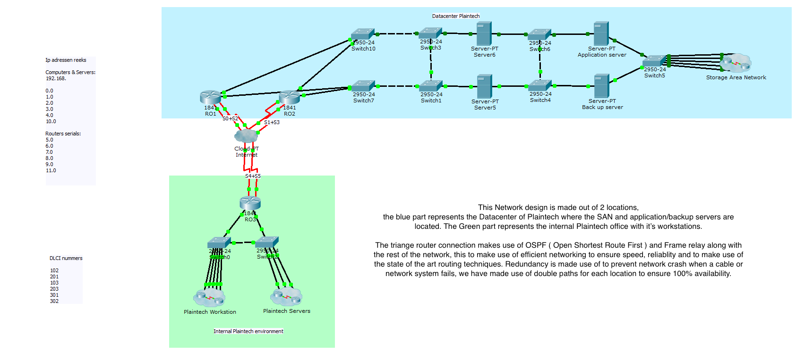
Our network design includes standard firewalls between the cloud and the routers as well as a firewall between the Storage area network and the wide area network to enforce security.

Security
To ensure that the systems of Plaintech are fully secure we make use of several different methods and passwords. The proces of logging onto the root server requires a mobile authentication token as well as a password for each user and the root. To then access the virtual machine through virt manager there is another specific password that must be used. If the administrator then wishes to open a virtual machine he must know the password configured by the client on the operating system. The client does not have to go through this long proces, the client only has to use his server IP address and VNC authentication code, then the client will be logged onto his/her server through an encypted cocnnection. The server’s firewall settings are configured correctly and that the least amount of ports are opened for VNC usage. We have tested the systems security with a penetration test to achieve the desired result of a very well protected Plaintech environment.

